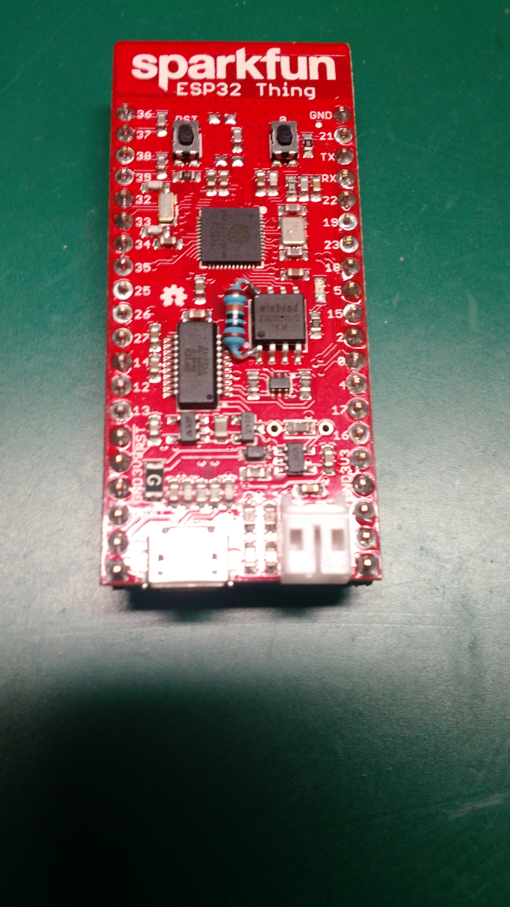
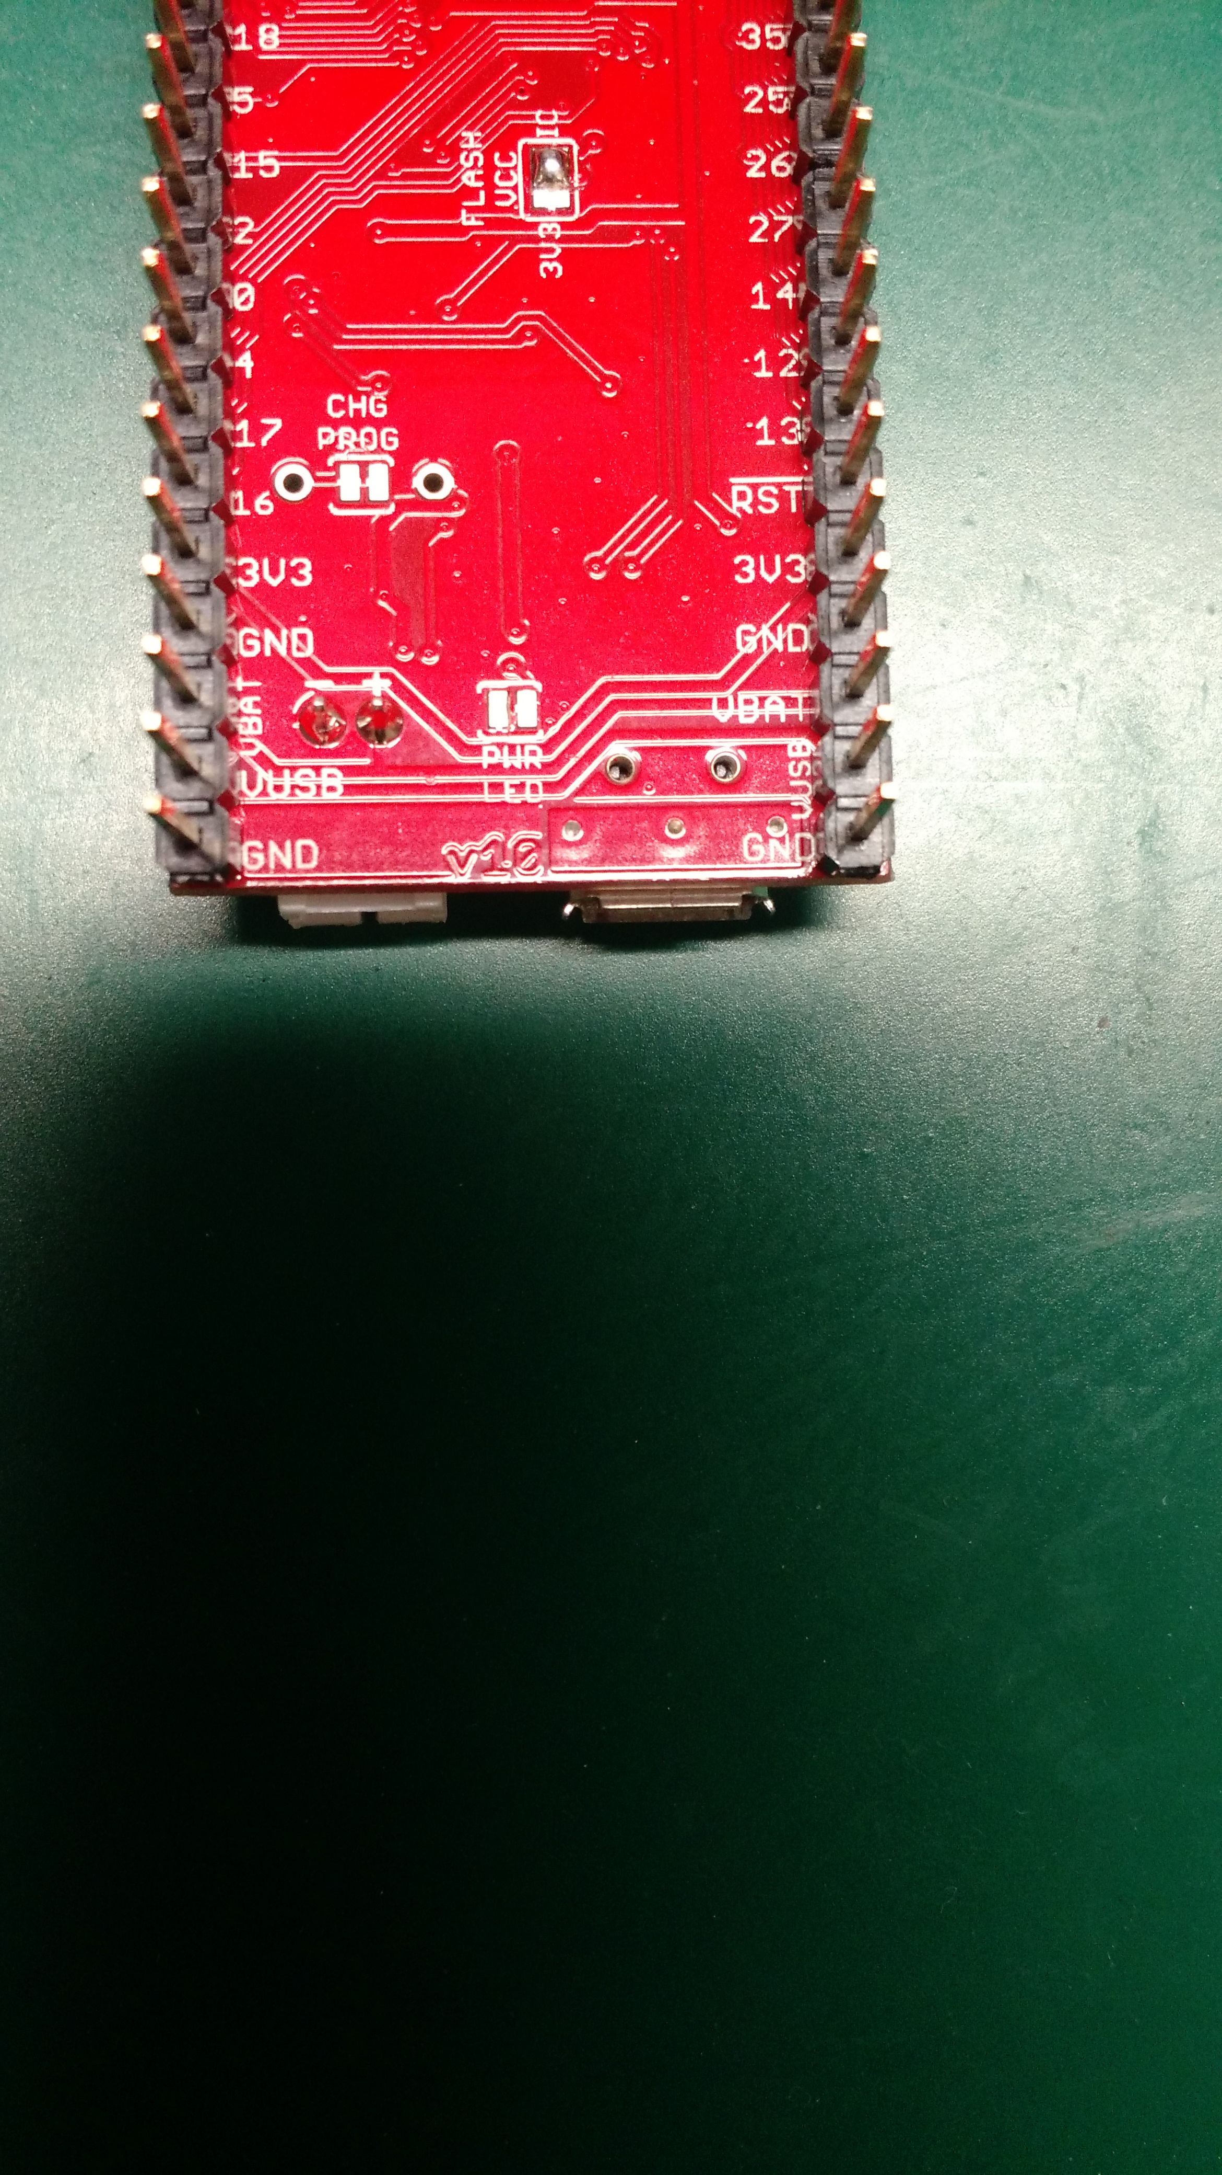

For this project, the Sparkfun ESP32 Thing required the following modifications to reduce its power consumption (details here: https://forum.sparkfun.com/viewtopic.php?f=14&t=45931 )

(blue): A pull-up resistor on pin 1 of the flash memory module. This is a 1M resistor connected to pin 8 (V_{CC}) of the flash module; this, in conjunction with (orange) allows the module to sleep when it is not in use (ESP32 is asleep).

(orange): Switch to IC instead of 3V3 for flash V_{CC}. This, in conjunction with (blue), is important for allowing the flash memory to disengage. Cut the trace between center and 3V3, solder between center and IC.

(green): Disable power LED. It is very difficult to see with the naked eye, so use a multimeter. Cut the trace between the pads.

